PROJECT: GBMES

QUALIFICATION TEST procedure

FOR

LCD DISPLAY WITH KEYBOARD & TRACKBALL

BEL Part No: 4461 722 601 34

(Designed by BEL – Hyderabad)

Prepared By
BEL-Hyderabad
Checked By
BEL QC - Hyderabad

Approved By
DGAQA

The Document is supplied on the express terms that it is to be treated as confidential and that it may not be copied, used or disclosed to others for any purpose except as authorized by Bharat Electronics, Hyderabad.

Bharat Electronics
Industrial Estate, Nacharam,
Hyderabad -500076,
Telangana,
INDIA.  Telephone: | 040 27194208
Fax: | 040 27151243

ISS | PAGE NO. | CP NO. | DATE | CHANGE | APPROVED BY
P1 |  |  | 10.06.16 | ORIGINAL

THIS IS AN ELECTRONICALLY APPROVED DOCUMENT, HENCE DOES NOT REQUIRE SIGNATURE

This document describes the procedure for carrying out Qualification Tests (First
Article Tests) on LCD DISPLAY WITH KEYBOARD & TRACKBALL

THIS IS AN ELECTRONICALLY APPROVED DOCUMENT, HENCE DOES NOT REQUIRE SIGNATURE

CONTENTS

SL.NO. | DESCRIPTION | PAGE NO.
1 | Introduction | 5
1.2 | Reference Documents | 5
2 | Specifications | 6
3 | Software | 6
4 | Test Equipment Required | 7
5 | Physical Inspection | 7
6 | Functional Test Procedure | 7
7 | Qualification Test Specifications | 8
8 | ESS Specifications | 11
9 | EMI / EMC Test Specifications | 11
10 | Qualification Test Procedure | 12
11 | EMI / EMC Test Procedure | 18
12 | Test Data Records | 34
13 | Defect Investigation Report | 36

- INTRODUCTION:
This document outlines the procedure for conducting qualification tests for the LCD
DISPLAY WITH KEYBOARD & TRACKBALL which is used GBMES system.
This item is being supplied by M/s Datasol Pvt Limited, Bangalore.
This item is mounted in 19 inch rack inside the shelter of Receiving Station Vehicle-1, Vehicle-2 and Control station. Hence, this is a Protected Unit.
This item is listed under the following in the contract for GBMES systems.
a) part of sl.no.10 in station list for Receiving station Vehicle-1
b) part of sl.no.9 in & station list for Receiving station Vehicle-2
c) part of sl.no.2 in station list of Control station

1.1. Brief Description: LCD DISPLAY WITH KEYBOARD & TRACKBALL It is Rugged 19” Rack mount 2U foldable display fitted with 88-key keyboard, trackball. and TFT LCD module using amorphous silicon TFT’s as active switching devices built for space-limited environments with high graphics demand. The built is 19.0 inch diagonally measured active area with SXGA resolutions. Each pixel is divided into RED, GREEN, BLUE dots which are arranged in vertical stripe and this display can display min.16.2 million colors.

1.2 REFERENCE DOCUMENTS
1.2.1 Qualification Test as per JSS 55555:2000
1.2.2 EMI/EMC Test as per MIL Std.461E.
1.2.3 MDI/BOM Part no: PP drawing includes BOM (PP No: 4461 722 601 34)
1.2.4 BEL PO No.. BEPO / HD4 / 4000057921 dated 05.04.2016
1.2.5 Approved Specifications are as per BEL PP drawing (PP No: 4461 722 601 34)
1.2.6 Contract No. AIR HQ/S/96135/69/1/ASR Dated 31/07/2015.
1.3 SOFTWARE CERTIFICATION - Not applicable
1.4 FAILURE ANALYSIS - Refer Appendix-A
1.5 MTBF Value of the Sub Assy: Ref BEL letter no. 4706/07/12 dtd 19th Aug 2016 to
AHQ.

2.0 SPECIFICATIONS
2.1 Technical Specifications:
- MONITOR: Anti-Glare polarizer product, wide temp liquid crystal, 2 channel LVDS interface, LED side mounting backlight, min.16.2 million colors, data enable signal mode, side mounting frame, green product.
- KEYBOARD / SLP: 88 keys with 10-key numeric pad green backlit keys integrated trackball. It is built into a rugged ABS polycarbonate case. It features green LED backlighting for use in low-light environments, and boasts an integrated touchpad that is designed with gloved-use in mind. Its slim features make it ideal for use on carts, wall mounts and other areas where space is at a premium.
- TRACK BALL: USB biased Full customization of bezel color, various colors and stainless steel, three buttons switch and track ball to move cursor.
- POWER SUPPLY: Max output wattage 75.6 & DC output 12V 6.3A.

2.2. Input Power Supply Requirements:
230 V AC single phase, 50 Hz

2.3. Dimensions:
The following are the dimensions of various parts:
- Monitor : 460.0± 0.5 (H) X 483.0 ± 0.5 (W) X 7.0 (D: max).
- Functional Keyboard : 11.80± 10(H) X 6.79±.10 (W) X1.35 (D: max).
- Power Supply : 33.528 (H) X 50.038 (W) X 150.114 (D: max).
- Track Ball : 58 (H)x 78 (W) x 36.17 (D)

2.4. Weight: 16 Kgs (approx.)

3.0 SOFTWARE :
Module is not software driven, hence documentation is not applicable

4.0 TEST EQUIPMENT REQUIRED:
4.1 CPU of a standard PC - 1 No. (Straight)
4.2 Power cables - 2 Nos.
4.3 Video cable - 1 No.
4.4 USB Cables - 2 Nos.

5.0 PHYSICAL INSPECTION:

5.1 Visual :
1.Check the Display for any damages
2. Check if the power circular connector is properly mating at the Dispaly end and also clearly inserted at the power socket.
3. Check all the connectors power & signal for any loose pins/wires.
4.Note down the result in TDR-1.

5.2 Dimensions & Drawing Verification:
1. Physical inspection of the unit is to be carried out wrt dimensions, mounting and other details as per drawing and note down the measured dimensions in TDR-1.

6.0 Functional Test Procedure:
1. Connect the Display to the CPU of a PC. After switching ON the power to Display
check the system booting and display seen on the screen of Display.
2. Check the functionality of the keyboard by typing &Tack ball by right clicking / scrolling the
ball.
3. Note down the results in TDR-2.
4. After checking, shutdown the system and switch off the Display Unit.

7.0 Qualification Test Specifications:
Reference Std: JSS 55555:2000, L2(H) classification for partially protected units mounted in wheeled vehicles. All the Qualification tests are to be conducted at approved test facilities only.

Sl.  No | Test Name | Specification | Remarks
 | Vibration  (Endurance) | Sinusoidal sweep vibration,  5-8Hz: ±6 mm constant displacement.  8-500Hz: ±1.5g mm constant displacement.  Sweep rate: 1 oct/min  Equipment will be in on OFF condition  Test duration: 1 hour in each X,Y,& Z axis  Ref:JSS 55555:2000,  Test No:28  Table:4.28.2  SL No : 1b | Switch ON the EUT and carry PC at the End of testing after each axis
2a | High Temperature  (operational) | Temp: 55±3°C  Duration: 16 Hrs,  Test Condition K,  Ref: JSS 55555:2000,  Test No:17  Procedure:6 | PC during last 30 minutes
2b | High Temperature  (Storage) | Temp:70±3°C  Duration: 16 Hrs,  Test Condition K,  Ref: JSS 55555:2000,  Test No:17  Procedure:6 | PC after 2-4 hours recovery at the room temperature
3 | Damp Heat | Temp :+ 40° C ± 2° C  RH :95% ±5%  Duration : 16 hours  Ref: JSS 55555:2000,  Test No:10  Procedure:6 | PC during last 30 minutes
4a | Low Temperature  (operational) | Temp :-10° C ± 3° C  Duration: 16 hours  Test Condition: H  Ref: JSS 55555:2000,  Test No:20  Procedure:4 | PC during last 30 minutes
4b | Low Temperature  (Storage) | Temp :-20° C ± 3° C  Duration: 16 hours  Test Condition: J  Ref: JSS 55555:2000,  Test No:20  Procedure:4 | PC after 2-4 hours recovery at the room temperature
5 | Altitude | Temp :-10° C ± 3° C  Altitude: 4160 meters for 16 hours  Test Condition: L2A2  Ref: JSS 55555:2000,  Test No:3  Table:4.3.2 , Procedure:5 | PC during last 30 minutes
6 | Rapid temperature cycling test | This item is a fully protected unit housed inside shelter in a rack where the temperature is maintained and there will be no rapid changes in temperature. Hence this test is omitted.
7 | Sealing | This is not a Hermetically sealed item, hence this test is not applicable.
8 | Dust | This item is a housed inside shelter and fixed in a rack. This being an LCD monitor, this test is omitted.
9 | Tropical exposure | This item is housed inside a shelter, fixed in a rack. This being an LCD monitor, this test is omitted.
10 | Mould growth | This item is a housed inside shelter and permanently fixed in a rack. This being an LCD monitor, this test is omitted.
11 | Salt corrosion | This item is a fully protected unit housed inside shelter, where the item is not exposed to saline environment. Hence this test is omitted.
12 | Contamination | This item is a fully protected unit housed inside shelter and is not likely to be exposed to contamination from fuels, oils and such other substances. Hence this test is omitted.
13 | Drop | This item is a housed inside shelter and permanently fixed in a rack and is not likey to be dropped. Hence this test is omitted.
14 | Toppling | This item is a housed inside shelter and permanently fixed in a rack. Hence this test is omitted.
15 | Bump | This item is a housed inside shelter and permanently fixed in a rack. This being an LCD monitor and since vibration is already included, this test is omitted.
16 | Roadability | Vibration is feasible and is included for this item, hence this test is not applicable

8.0 ESS TEST SPECIFICATIONS

DETAILED ESS TEST SPECIFICATION AS PER MIL STD- 810E
Sl No | PARAMETER | TEST DESCRIPTION |  | Remarks
1 | Random vibration-pre Thermal cycling | 20Hz-80Hz , sloping at +3dB/octave:  80Hz to 350Hz, 0.02 g2/Hz PSD, 350-2000Hz,sloping at -3dB/octave.  5min. per axis on all three axes.
2 | Thermal cycling | -10° C to +55° C  Dwell AT -10° C and +55° C for 90 minutes.  No.of cycles:10  Rate of cooling/heating: 10° C /minute
3 | Random vibration-post Thermal cycling | 20Hz-80Hz , sloping at +3dB/octave:  80Hz to 350Hz, 0.02 g2/Hz PSD, 350-2000Hz,sloping at -3dB/octave. 5Min.per axis on all three axes.

9.0 EMI / EMC TEST SPECIFICATIONS
EMI/EMC Specifications : As per MIL STD-461E/F
Sl.No | PARAMETER | Test | TEST DESCRIPTION | Remarks
1. | MIL STD-461E/F | CE102, | Conducted Emissions, Power Leads. 10 KHZ to 10 MHZ
2. | MIL STD-461E/F | RE102, | Radiated Emission, Electric field. 2 MHZ to 18 GHZ
3. | MIL STD-461E/F | CS101, | Conducted Susceptibility, Power Leads, 100 Hz to 150 KHz
4. | MIL STD-461E/F | CS114, | Conducted susceptibility, bulk cable injection. 10 KHZ to 200 MHZ
5. | MIL STD-461E/F | CS115, | Conducted susceptibility, bulk cable injection. Impulse Excitation
6. | MIL STD-461E/F | CS116, | Conducted susceptibility, damped sinusoidal transients.Cables and power leads.10 KHZ to 100 MHZ
7. | MIL STD-461E/F | RS103 | Radiated Susceptibility, Electric Field, 2 MHz to 40 GHz.

Initial Electrical Test
QT

Visual Test

Visual/Physical Test
Final Electrical Test

Flow Chart For Qualification Test

10.0 QUALIFICATION TEST PROCEDURE :

10.1 Vibration (Endurance)

Purpose
This test is performed to determine if test items can be operated under severe physical dynamic condition without experiencing physical damage or deterioration in performance.

Test Objectives
The primary objective of the test is to determine whether:-
      - The basic design is adequate to withstand the specification requirement.
      - Design modifications are necessary to make it withstand the test severities.
      - Incorporation of isolation mechanism required in the event of inadequacies due to constraints in the design to make it functional under the severe dynamic conditions.
Test Specification:
Vibration | Sinusoidal sweep vibration:  5 to 8 Hz : ±6 mm constant displacement  8 to 500 Hz : ±1.5g constant acceleration  Sweep rate:1 oct/min  Equipment will be in ON condition  (only power ON LED will glow).  Test duration: 1 hour in each X,Y&Z axis.

Test Procedure
Step 1-Mount the test item with its fixture on the vibration table.
Step 2-Expose the test item in ‘unpacked’ and ‘switched-on’ condition to the Vibration test level and duration as specified.
Step 3-Inspect the test item and verify its functionality and record the results.
Step 4-Repeat steps 2 & 3 for each axis.

10.2 High Temperature
Purpose
High temperature test is performed to determine if test items can be operated under hot environmental conditions without experiencing physical damage or deterioration in performance.
Test Objectives
The primary objectives of the High Temperature test are to determine if:-
    - The test item will operate without degradation after storage in a climatic which induces high temperature within the test item.
    - The test item can be operated and handled without affecting its integrity in a high temperature climate.
    - The test item is safe during and following high temperature exposure

Operational |  | Storage
Temperature | +55° C ±3 C | Temperature | +70° C ±3° C
Duration | 16 hours | Duration | 16 hours
Condition | K | Condition | K

Test Procedure
10.2.1 Operational
Step 1 - With the test item placed in the chamber in its ‘unpacked’ and ‘switched-on’ condition, adjust the chamber air conditions to the specified operational test temperature level of 55⁰C.
Step 2 - Expose the test item to this temperature level till the stability is attained and then maintain for applicable hours.
Step 3 - Performance test the item and carryout operational check outs at 55⁰C during last 1 hour of the conditioning period and record the results in the test report.
Step 4 - Switch off the test item and adjust the chamber air temperature to standard laboratory ambient and maintain until temperature stabilization of the test item has been achieved.
Step 5 - Conduct a complete visual examination of the test item and
Step 6 - Conduct an operational checkout at ambient temperature.

10.2.2 Storage
Step 1 -With the test item placed in the chamber in its ‘unpacked’ and ‘switched-off’ condition, adjust the chamber air conditions to the specified storage of 70⁰C for applicable hours.
Step 2 -At the end of the test adjust the chamber air temperature to ambient conditions and bring down the temperature. Maintain until temperature stabilization of the test item has been achieved.
Step 3 -Conduct complete visual and operational check outs of the test item and record the results in the test report.
10.3. Damp Heat
Specifications
Temperature | +40° C ±2° C
Duration | 16 hours
RH Value | 95 ± 3 %

Objective

To determine the suitability of electronic and electrical equipment for use under conditions of high humidity.

Test Procedure
The equipment shall be visually examined and shall be electrically and mechanically checked as specified.
Conditioning
Step1: The equipment under test shall be subjected to the test in its' unpacked' and 'switched-off' condition.
Step2: The equipment under test, while being under the laboratory atmospheric conditions shall be introduced into the chamber, the latter also being under the same conditions. The temperature and relative humidity of the chamber shall then be raised to 40ºC ± 2 ºC and not less than 95 percent respectively, over a period of not less than one hour.
Step3: The equipment shall be conditioned under these conditions for a period of 16 hours.
Step4: During the last 30 minutes of the period, the equipment shall be switched on and a performance check, as specified, shall be carried out.

Step5: The temperature of the chamber shall then be restored to the laboratory atmospheric conditions in not less than an hour. Saturation of the chamber atmosphere with water vapor shall occur during this period. The equipment shall then be exposed to these conditions for a period of not less than 3 hours.
Recovery
The equipment shall be recovered from the chamber and shall be allowed to remain under standard recovery conditions for a period of 2 to 4 hours.
Final Measurements
The equipment shall be visually examined and shall be electrically and mechanically checked as specified and record the results.

10.4 Low Temperature
Purpose
Low temperature chamber tests are performed to determine if material can be stored, manipulated, and operated under pertinent low temperature conditions without experiencing physical damage or deterioration in performance.
Test Objectives
The primary objectives of the low temperature test are to determine if:
1.The test item can meet the performance specifications during operation in a cold environment.
2. The test item can be operated safely during or following low temperature exposure.
Test Specification

Operational |  | Storage
Temperature | -10° C ±3° C | Temperature | -20° C ±3° C
Duration | 16 hours | Duration | 16 hours
Condition | H | Condition | J
Test Procedure
10.4.1 Operation
Step1: With the test item placed in the chamber in its ‘unpacked’ and ‘switched-on’ condition, adjust the chamber air conditions to the specified operational test temperature of -10⁰C. Maintain until temperature stabilization of the test item has been achieved and soak the equipment for applicable hours.
Step 2: Conduct an operational checkout of the test item after soaking period during last 1 hour.
Step 3: Document the results in the recoded on test report.
Step 4: Switch off the test item and adjust the chamber air temperature to standard laboratory ambient and maintain until temperature stabilization of the test item has been achieved.
Step 5 - Conduct a complete visual examination of test item.
Step 6 - Conduct an operational checkout at ambient temperature.
10.4.2 Storage
Step 1 - With the test item placed in the chamber in its ‘unpacked’ and ‘switched-off’ condition, adjust the chamber air conditions to the specified storage of -20⁰C. Maintain until temperature stabilization of the test item has been achieved and soak the equipment for applicable hours.
Step 2 – After the test conduct a complete visual examination of the test item.
Step 3 - Conduct an operational checkout of the unit after the test or during the recovery
period and document the results.

10.5 Altitude
Objective
To determine the suitability of electronic and electrical equipment for use under simultaneously applied Service conditions of low air pressure and high or low temperature.
Test Chamber
Step 1 - The altitude chamber shall be capable of maintaining its working space at the appropriate low air pressure severity within a tolerance of ± 5 percent. In addition, the chamber shall also be capable of meeting all the requirements specified for test chamber for the high temperature test and the low temperature test.
Step 2 - The altitude chamber shall also be capable of maintaining a relative humidity of not less than 95 percent as required for procedure 5.

Test Procedure
Initial Measurements
The equipment shall be visually examined and shall be electrically and mechanically checked as specified.
Conditioning
The equipment under test shall be subjected to this test in 'unpacked' condition. The equipment shall be subjected to procedure 5 as specified. At the beginning of the procedure the equipment shall be in its 'switched-off' condition.
Procedure 5
Step 1 - The equipment under test, while being under laboratory atmospheric condition, shall be introduced into the chamber, the latter also being under the same conditions. The temperature of the chamber shall then be lowered to one of the following test conditions, as specified:
Step 2 - The air pressure inside the chamber shall then be reduced to a value corresponding to the test conditions, given in the Table 5 as specified.
- Test condition : -10ºC ± 3 deg C

TABLE 5: TEST CONDITIONS FOR ALTITUDE
TEST CONDITION | ALTITUDE IN METRES | AIR PRESSURE IN kPa
A2 | 4,160 | 60.0

Step3 - The conditions of temperature and air pressure as specified in Step 1 and 2 shall be maintained for a period of 16 hours.
Step 4 - During the last 30 minutes of the period, the equipment shall be 'switched on' and a performance check shall be carried out, as specified.
Step 5 - The temperature of the chamber shall then be allowed to rise, at such a rate that it would attain laboratory atmospheric conditions in not less than one hour and not more than four hours.
Step 6 - When the equipment temperature has reached a value between 0 and 10º C, the air pressure inside the chamber shall be restored to laboratory atmospheric conditions within 30 minutes.
Step 7 - A performance check shall then be carried out as specified.

11. EMI/EMC Test Procedures
11.1 CE102 Conducted Emissions, Power Leads, 10 kHz to 10 MHz

11.1.1 CE102 Applicability:
This requirement is applicable from 10 kHz to 10 MHz for all power leads, including returns that obtain power from other sources not part of the EUT.
11.1.2 CE102 Limit:
The Limit curve shown below is the basic curve, 9dB relaxation is given for the EUT with 220 V voltage source. The limit curve will be 9dB elevated from as shown in Figure-1 Conducted emissions on power leads shall not exceed the applicable values shown on Figure - 1.

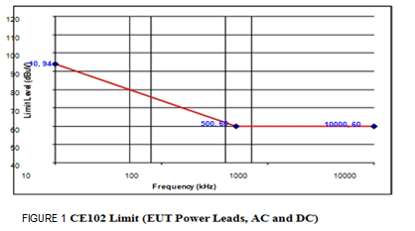

11.1.3 CE102 Test Procedure:

Perform emission data scans using the measurement setup given in Figure - 2
a) Perform Calibration as per MIL-STD-461E (CE102) Requirements
b) Turn on the EUT and allow a sufficient time for stabilization.
c) Select an appropriate lead for testing.
d) Scan the measurement receiver over the applicable frequency range.
e) Repeat (c) and (d) for each power lead.

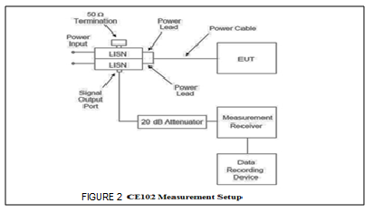

11.2 RE102 Radiated Emissions, Electric Field, 2 MHz to 18 GHz.

11.2.1 RE102 Applicability:
This requirement is applicable for radiated emissions from equipment and subsystem enclosures, all interconnecting cables, and antennas designed to be permanently mounted to EUTs (receivers and transmitters in standby mode). The requirement does not apply at the transmitter fundamental frequencies.
As the EUT is a Ground based system, the Start frequency of this test is 2 MHz.

11.2.2 RE102 Limit:
Electric field emissions shall not be radiated in excess of that shown in Figure 3. Above 30 MHz, the limits shall be met for both horizontally and vertically polarized fields.

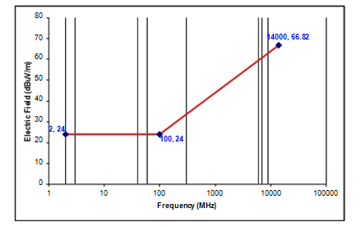
Figure 3: RE102 Limit for Ground Applications

11.2.3 RE102 Test Procedure:
a) Perform emission data scans using the measurement setup given in Figure 4 Ensure that the EUT is oriented such that the surface that produces the maximum radiated emissions is towards the front edge of the test setup boundary.
b) The Antenna Positioning should be done as indicated in Figure 5. The number of required antenna positions depends on the size of the test setup boundary and the number of enclosures included in the setup. Guidelines given in MIL-STD-461E, RE102 Requirements should be followed to determine the individual antenna positions.
c) Verify that the ambient is at least 6 dB below the allowable specified limits when the tests are performed in a shielded enclosure. Take plots of the ambient when required.
d) Perform Calibration as per MIL-STD-461E (RE102) Requirements
e) Turn on the EUT and allow a sufficient time for stabilization.
f) Using the measurement path of Figure.4, determine the radiated emissions from the EUT and its associated cabling.
g) Scan the measurement receiver for each applicable frequency range, using the bandwidths and minimum measurement times in Emission Test Parameters.
h) Above 30 MHz, orient the antennas for both horizontally and vertically polarized fields.
i) Take measurements for each antenna position determined above.

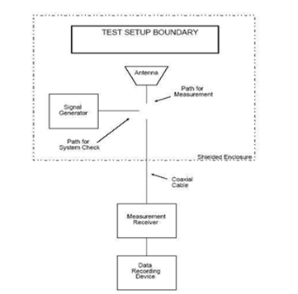
Figure 4: RE102 Basic Test Setup

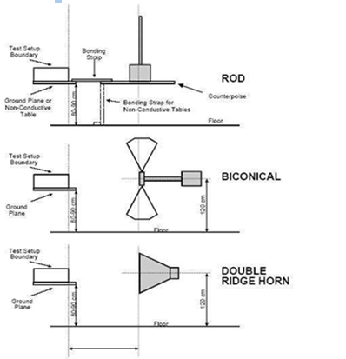

Figure 5 Antenna Positioning

11.3 CS101 Conducted Susceptibility, Power Leads, 100 Hz to 150 KHz

11.3.1 CS101 Applicability:
This requirement is applicable to equipment and subsystem AC and DC input power leads, not including returns. If the EUT is AC operated, this requirement is applicable starting from the second harmonic of the EUT power frequency and extending to 150 kHz. As the EUT is 50 Hz AC operated, this requirement is applicable over the frequency range of 100 Hz to 150 kHz.

11.3.2 CS101 Limits:
The EUT shall not exhibit any malfunction, degradation of performance, or deviation from specified indications, beyond the tolerances indicated in the individual equipment or subsystem specification, when subjected to a test signal with voltage levels as specified in Figure 6.The requirement is also met when the power source is adjusted to dissipate the power level shown in Figure 7 in a 0.5-ohm load and the EUT is not susceptible.

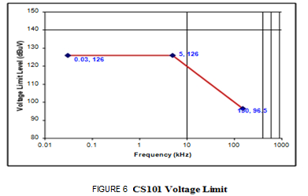

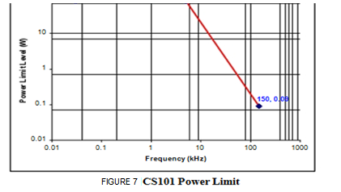

11.3.3 CS101 Test Procedure:

a) Perform Calibration as per MIL-STD-461E (CS101) Requirements
b) Turn on the EUT and allow a sufficient time for stabilization.
c) Set the signal generator to the lowest test frequency. Increase the signal level until
the required voltage or power level is reached on the power lead.
d) While maintaining at least the required signal level, scan through the required
frequency range at a rate no greater than specified in Susceptibility Test
Parameters .
e) Susceptibility evaluation:
(i) Monitor the EUT for degradation of performance.
(ii) If susceptibility is noted, determine the threshold level and verify that it is above
the limit.
f) Repeat (c) through (e) for each power lead, as required.

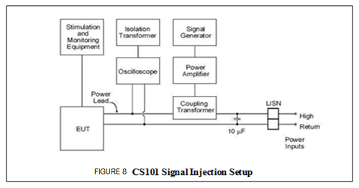

11.4 CS114 Conducted Susceptibility, Bulk Cable Injection, 10 kHz to 200 MHz.

11.4.1 CS114 Applicability:
This requirement is applicable to all interconnecting cables, including power cables.

11.4.2 CS114 Limit:
The EUT shall not exhibit any malfunction, degradation of performance, or deviation from specified indications beyond the tolerances indicated in the individual equipment or subsystem specification, when subjected to a injection probe drive level which has been pre-calibrated to the appropriate current limit and is modulated as specified below. The appropriate limit curve given in Figure 9 shall be selected. Requirements are also met if the EUT is not susceptible at forward power levels sensed by the coupler that are below those determined during calibration provided that the actual current induced in the cable under test is 6 dB or greater than the calibration limit.

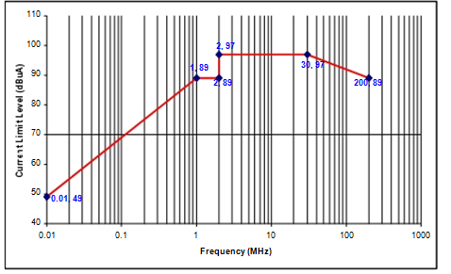

Figure 9 : CS114 Limit for Ground Equipment.

11.4.3 CS114 Test Procedure:
a) Perform Calibration as per MIL-STD-461E (CS114) Requirements.
b) Turn on the EUT and allow a sufficient time for stabilization.
c) Susceptibility evaluation:
(i) Set the signal generator to 10 kHz with 1 kHz pulse modulation, 50% duty cycle.
(ii) Apply the forward power level needed to maintain the current amplitude
required (as per CS114 Limit) determined during calibration to the injection probe while monitoring the induced current.
(iii) Scan through the required frequency range at a rate no greater than specified
in Susceptibility Test Parameters while maintaining the forward power level at
the calibration level determined, or the maximum current level for the applicable limit, whichever is less stringent.
(iv) Monitor the EUT for degradation of performance during testing.
(v) Whenever susceptibility is noted, determine the threshold level and verify that it is above the applicable requirement.
(vi) For EUTs with redundant cabling for safety critical reasons such as multiple data buses, use simultaneous multi-cable injection techniques.
d) Perform the above procedures on each cable bundle interfacing with each electrical
Connector on the EUT including complete power cables (high sides and returns). Also perform the procedures on power cables with the power returns and chassis grounds (green wires) excluded from the cable bundle. For connectors, which include both interconnecting leads and power, perform the procedures on the entire bundle, on the power leads (including returns and grounds) grouped separately, and on the power leads grouped with the returns and grounds removed.

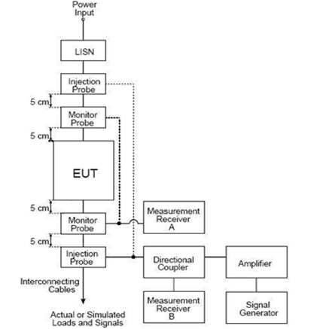

Figure 10: CS114 Bulk Cable Injection Block Diagram

11.5 CS115: Conducted Susceptibility, Bulk Cable Injection, Impulse Excitation.

11.5.1 CS115 Applicability:
This requirement is applicable to all aircraft, space and ground system interconnecting cables, including power cables.

11.5.2 CS115 Limit:
The EUT shall not exhibit any malfunction, degradation of performance, or deviation from specified indications beyond the tolerances indicated in the individual equipment or subsystem specification, when subjected to a pre-calibrated signal having rise and fall times, pulse width, and amplitude as specified in Figure 11 at a 30 Hz rate for one minute.

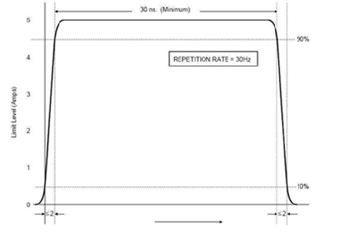
Figure 11: CS115 Signal Characteristics

11.5.3 CS115 Test Procedure:

a) Perform Calibration as per MIL-STD-461E (CS115) Requirements.
b) Turn on the EUT and allow a sufficient time for stabilization.
c) Susceptibility evaluation:
(i) Adjust the pulse generator, as a minimum, for the amplitude setting determined during calibration.
(ii) Apply the test signal at the pulse repetition rate and for the duration specified in the requirement.
(iii) Monitor the EUT for degradation of performance during testing.
(iv) Whenever susceptibility is noted, determine the threshold level and verify that it is above the limit.
(v) Record the peak current induced in the cable as indicated on the oscilloscope.
(vi) Repeat (i) through (v) on each cable bundle interfacing with each electrical connector on the EUT. For power cables, perform (i) through (v) on complete power cables (high sides and returns)and on the power cables with the power returns and chassis grounds (green wires) excluded from the cable bundle. For connectors which include both interconnecting leads and power, perform (i) through (v) on the entire bundle, on the power leads (including returns and grounds) grouped separately, and on the power leads grouped with the returns and grounds removed.

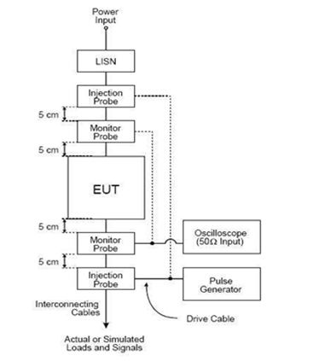

Figure 12 : Typical Setup for CS115 Bulk Cable Injection

11.6. CS116: CS, Damped Sinusoidal Transients, Cables and Power Leads, 10 kHz to 100 MHz.

11.6.1 CS116 Applicability:
This requirement is applicable to all interconnecting cables, including power cables and individual high side power leads. Power returns and neutrals need not be tested individually.

11.6.2 CS116 Limit:
The EUT shall not exhibit any malfunction, degradation of performance, or deviation from specified indications beyond the tolerances indicated in the individual equipment or subsystem specification, when subjected to a signal having the waveform shown in Figure 13 and having a maximum current as specified in Figure 14.

The limit is applicable across the entire specified frequency range. As a minimum, compliance shall be demonstrated at the following frequencies: 0.01, 0.1, 1, 10, 30, and 100 MHz. If there are other frequencies known to be critical to the equipment installation, such as platform resonances, compliance shall also be demonstrated at those frequencies. The test signal repetition rate shall be no greater than one pulse per second and no less than one pulse every two seconds. The pulses shall be applied for a period of five minutes.

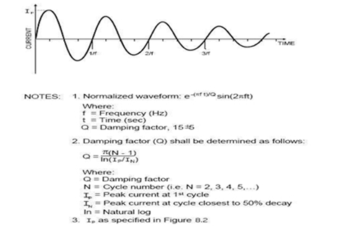

Figure 13: Typical CS116 Damped Sinusoidal Waveform.

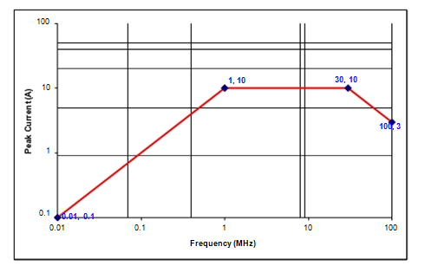

Figure 14: CS116 Current Limit.

11.6.3 CS116 Test Procedure :

a) Perform Calibration as per MIL-STD-461E (CS116) Requirements.
b) Turn on the EUT and measurement equipment to allow sufficient time for
stabilization .
c) Set the damped sine generator to a test frequency.
d) Apply the test signals to each cable or power lead of the EUT sequentially. Slowly increase the damped sine-wave generator output level to provide the specified current, but not exceeding the pre-calibrated generator output level. Record the peak current obtained.
e) Monitor the EUT for degradation of performance.
f) If susceptibility is noted, determine the threshold level and verify that it is above the specified requirements.
g) Repeat (c) through (e) for each test frequency as specified in the requirement. Repeat testing for the power-off condition.
h) Perform the above procedures, using the EUT test setup on each cable bundle
interfacing with each connector on the EUT including complete power cables. Also perform tests on each individual high side power lead (individual power returns and neutrals are not required to be tested).

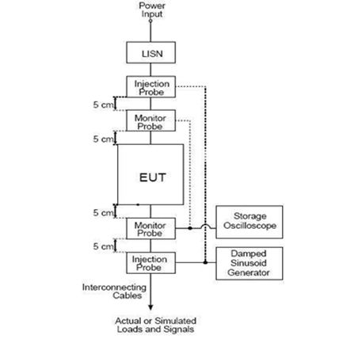

Figure 15: Typical Setup for Bulk Cable Injection of Damped Sinusoidal Transients

11.7 RS103 Radiated Susceptibility, Electric Field, 2 MHz to 40 GHz.

11.7.1 RS103 Applicability:
This requirement is applicable to equipment and subsystem enclosures and all interconnecting cables. The requirement at the tuned frequency of an antenna-connected receiver is 20 dB above the RE102 limit associated with the particular platform application.
11.7.2 RS103 Limit:
The EUT shall not exhibit any malfunction, degradation of performance, or deviation from specified indications, beyond the tolerances indicated in the individual equipment or subsystem specification, when subjected to the radiated electric fields of 50 V/m throughout the frequency range of 2 MHz to 40 GHz and modulated as specified below. Up to 30 MHz, the requirement shall be met for vertically polarized fields. Above 30 MHz, the requirement shall be met for both horizontally and vertically polarized fields. Circular polarized fields are not acceptable.

11.7.3 RS103 Test Procedure:
a) Maintain a basic setup as given in Figure 16. Electric field sensors are required from 2 MHz to 1 GHz. Either field sensors or receive antennas may be used above 1 GHz.
b) The number of required antenna and sensor positions depends on the size of the test setup boundary and the frequency of radiation. Guidelines given in MIL-STD-461E, RS103 Requirements should be followed to determine the individual antenna and sensor positions.
c) Assess the test area for potential RF hazards and take necessary precautionary steps to assure safety of test personnel.
d) Perform Calibration as per MIL-STD-461E (RS103) Requirements
e) Turn on the EUT and allow a sufficient time for stabilization.
F) E-Field Sensor Procedure: As shown in Figure 16
(i) Set the signal source to 1 kHz pulse modulation, 50% duty cycle, and using
appropriate amplifier and transmit antenna, establish an electric field at the test start frequency. Gradually increase the electric field level until it reaches the applicable limit.
(ii) Scan the required frequency ranges in accordance with the rates and durations
specified in Susceptibility Test Parameters. Maintain field strength levels in
accordance with the applicable limit. Monitor EUT performance for susceptibility
effects.
g) Receive Antenna Procedure:
(i) Remove the receive antenna and reposition the EUT in conformance with Figure 17.
(ii) Set the signal source to 1 kHz pulse modulation, 50% duty cycle. Using an appropriate amplifier and transmit antenna, establish an electric field at the test start frequency. Gradually increase the input power level until it corresponds to the applicable level recorded during the calibration routine.
(iii) Scan the required frequency range in accordance with the rates and durations specified in Susceptibility Test Parameters while assuring the correct transmitter input power is adjusted in accordance with the calibration data collected. Constantly monitor the EUT for susceptibility conditions.
h) If susceptibility is noted, determine the threshold level and verify that it is above the limit.
i) Perform testing over the required frequency range with the transmit antenna vertically polarized. Repeat the testing above 30 MHz with the transmit antenna horizontally polarized.
j) Repeat the test procedures for each transmit antenna position required.

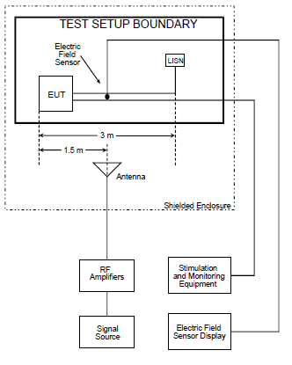

Figure 16: RS103 Basic Test Equipment Configuration (Using Sensor)

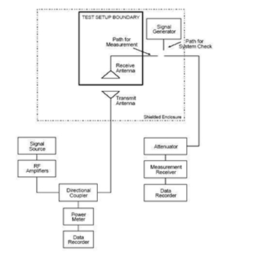

Figure 17: RS103 Basic Test Equipment Configuration (Using Receive Antenna)

Recovery - The equipment shall then be removed from the chamber and shall be restored to laboratory atmospheric conditions within 30 minutes for a period of 2 to 4 hours.
Final Measurements - The equipment shall then be visually examined and shall be electrically and mechanically checked as specified and record the results.

12.0 Defect / Failure Analysis : Defect/failure investigation is to be done, entered in the format mentioned in Appendix-A for any failure during any of the tests and filed with the results.

TEST DATA RECORD-1

Sl.no. Date:
Test condition:

1. PHYSICAL INSPECTION
S.No | Test | Requirement | Result
1 | KVM damages check | No damages | OK /NOT OK
2 | Power circular mating and insertion at the power socket. | Proper fitment | OK /NOT OK
3 | All the connectors power & signal | No loose pins / wires | OK /NOT OK

2. Dimensional Check:
S.No | Description | Specified Dimensions(mm) | Measured  Dimensions(mm) | Result
1 | Width | 425 ± 0.5 |  | OK /NOT OK
2 | Height | 88 ± 0.5 |  | OK /NOT OK
3 | Depth | 500 ± 0.5 |  | OK /NOT OK
4 | Weight | <16 Kgs |  | OK /NOT OK

RESULT : OK / NOT OK

OEM .Rep BEL-QC.Rep DGAQA Rep

TEST DATA RECORD-2

Sl.no. Date:
Test condition:

FUNCTIONAL TEST:
S.No | TEST | REQUIREMENT | RESULT
1 | Power On Self Test:
1 | Fuctionality of KVM:  System booting display seen on the screen of KVM. | Observe:  Resolution up to 1280 X 1024 | OK / NOT OK
2 | Functionality of Keyboard / Track Ball:  Functionality of the keyboard by typing &Tack ball by right clicking / scrolling the ball. | Test by pressing the keys at keyboad & check the same is display on the screen at KVM.  Right click on Track Ball& also by moving cursor to check the mouse is working fine. | OK / NOT OK

RESULT : OK / NOT OK

OEM .Rep BEL-QC.Rep DGAQA Rep

Appendix A

DIR  Defect  Investigation  Report | Unit Description:  Unit Sl. No.:
DI NO. | TYPE OF MODIFICATION
DATE: | H/W | S/W N/A |  | BOTH N/A
S/W VERSION: N/A |  |  | CHECK SUM:
PROBLEM REPORTED DURING:

PROBLEM DESCRIPTION:

MODULE / COMPONENT AFFECTED:

DEFECT ANALYSIS & CAUSE OF PROBLEM:

REPAIR / REMEDIAL ACTION:

FOLLOW UP ACTION:

OEM .Rep BEL Design Rep BEL-QC.Rep DGAQA Rep

